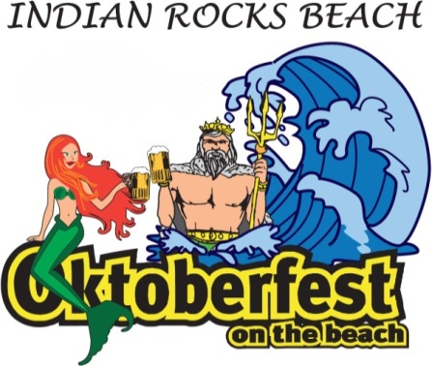

Oktoberfest on the Beach 2018 Silent Auction Agreement
Please submit this form by SEPTEMBER 1, 2018 for inclusion in printed material.
AUCTION ITEM DESCRIPTION: Please provide details such as brand, color, size, etc. Any promotional materials or photos are appreciated.
Click here to enter text.

Item Value: Click here to enter text.

DONOR INFORMATION

Name/Company: Click here to enter text.

Website address: Click here to enter text.

Contact Name: Click here to enter text.

Address: Click here to enter text.

Phone: Click here to enter text. Email: Click here to enter text.

All proceeds benefit the Indian Rocks Beach Community. Thank you for your support of IRB Action 2000, Inc. For questions, or to drop off your auction items, please contact Laurie Oates, 727-423-2015, rvplaurie@gmail.com.
Visit our website www.oktoberfestonthebeach.com Follow us on Facebook, Oktoberfestonthebeach

Silent Auction Use Only
Date form received: Click here to enter a date. | Item solicitor: Click here to enter text.
Item to be delivered/picked up by: Click here to enter text. | Date: Click here to enter a date.
Item location: Choose an item. | Display needs:

Action 2000, Inc. is a non-profit, tax-exempt, publicly supported organization under Section501(c)(3) of the IRS Code, and is incorporated and registered in Florida. All donations are tax deductible to the extent allowed by law. The official registration and financial information of the organization may be obtained from the Florida Department of State Division of Corporations by visiting www.sunbiz.org or calling (850) 245-6052. Registration does not imply endorsement. Form 6-12a

